FOR IMMEDIATE RELEASE

**The Inventions of Steve Wozniak**

*“My goal wasn’t to make a ton of money. It was to build good computers”*

Dublin, Ireland (October 26th, 2016) - A group of students from Trinity College Dublin, also known as ‘TechBytes’, focusses on the creations and innovations of electronic engineer, programmer and co-founder of Apple, Steve Wozniak, in their newly-aired program on RTE. This documentary answers the question of ”Who is Wozniak and what did he contribute to technology today?” for the viewers. He is one of the men responsible for the company we all know, Apple Inc, and for igniting the personal computer revolution. Without Wozniak, a good portion of the population would not be reading this article on iMacs, Macbooks or iPhones today. ‘TechBytes’ educates viewers on this significant figure, starting right from the beginning of his life.

# Steve Wozniak was born in San Jose, California, the son of Margaret Elaine (Kern) and Jacob Francis"Jerry"

# Wozniak. He is of Ukrainian and Swiss-German ancestry. The family immigrated to US.Before focusing his attention on Apple, he was employed at Hewlett-Packard where he designed calculators.

# In 1976, Wozniak designed the hardware, circuit board designs, and operating system for the Apple I. It was revolutionary as it was the first time a home computer generated a character and displayed it on a TV screen.Apple I stayed in production from April 1976 until September 1977, with a total run of around 200 units for $666.66 per unit. It was considered a huge success.

After the commercial success of the Apple I, in 1976 Wozniak helped found Apple Computer alongside Steve Jobs. Wozniak was crucial to the company's continued success as he designed the Apple II. It was the first personal computer with the ability to display colour graphics and had BASIC programming language built-in.

The Apple II became one of the first highly successful mass-produced personal computers. The Apple II cost $1,300 and almost six million series II were produced over 16 years.

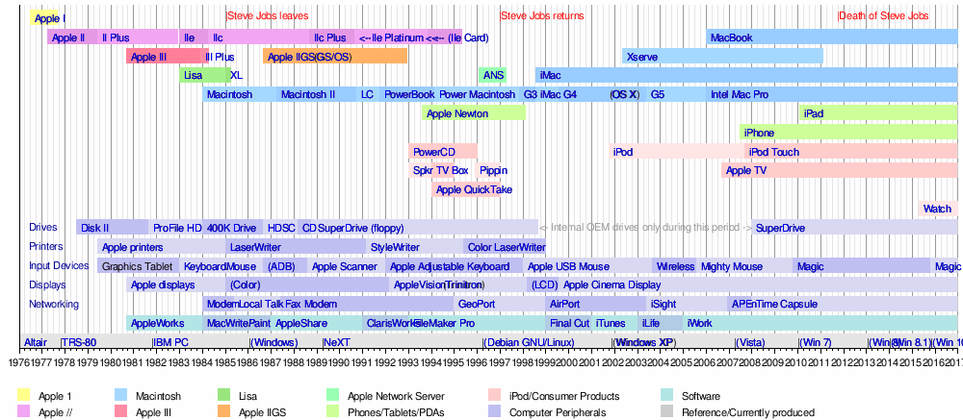

However, tragedy struck in 1981 as Wozniak suffered an aeroplane crash. After this he reduced his involvement with Apple and ceased to have any other major influences on computing. He still remains an employee of Apple and receives a stipend. Wozniak also had influence outside of Apple. He founded CL 9, which developed and brought the first programmable universal remote control to market in 1987.

Before Wozniak invented Apple I and Apple II, computers were considered impractical and boring. They occupied a large amount of space and were mostly used to do certain type of work. Wozniak made computers user-friendly so that almost anyone will feel comfortable using it. Compared to earlier computers, Apple I and Apple II had graphics. This was considered phenomenal at the time. The aspect of graphics is still significant, even today. We have improved and are continuing to develop computer graphics. All of these advances and discoveries started with that screen on Apple I created by Wozniak. Because of his work and contribution to the development of PC’S, computers have become popular and nowadays almost everyone owns a computer.

**About the Team**

TechBytes is a group of Irish students currently studying Computer Science in Trinity College Dublin. Our aim for this project is to provide information concerning the role of technology in Irish society. Members of TechBytes can be contacted for more information through the email addresses provided: [olorunns@tcd.ie](mailto:olorunns@tcd.ie)

[saphilli@tcd.ie](mailto:saphilli@tcd.ie)

[tprasad@tcd.ie](mailto:tprasad@tcd.ie)

[oreskovt@tcd.ie](mailto:oreskovt@tcd.ie)

**Sources**

(http://archive.woz.org/letters/general/63.html)

(Steve Wozniak Talks About HP,youtube.com)

*(Wozniak, Steve; Smith, Gina (2006). iWoz: Computer Geek to Cult Icon: How I Invented the Personal Computer, Co-Founded Apple, and Had Fun Doing It. W. W. Norton & Company.)*

*(*Freiberger, Paul*;* Swaine, Michael *(2000). Fire in the Valley. McGraw-Hill.)*

*(http://www.macworld.co.uk/feature/apple/history-of-apple-steve-jobs-what-happened-mac-computer-3606104)*

http://www.biography.com/people/steve-wozniak-9537334#synopsis